SIMATS ENGINEERING (SAVEETHA SCHOOL OF ENGINEERING)
Department of Computer Science and Engineering
CO2 ASSESSMENT TOOL 2 – Architecture Design Assignment

Course Code: | CSA10 / CSA1007 | Course Title: | Software Engineering
CO Assessed: | CO2 | Assessment: | Assessment Tool 2 – Architecture Design Assignment
Weightage: | 20% | Total Marks: | 25
CO2 Statement: | Perform detailed requirements analysis, design scalable architectures, and prioritize features with a focus on cross-disciplinary skills
Student Name: | Jeevan R | Reg. No.: | 192524007
Date: | 28/07/26 | Duration: | 60 minutes

Code of Conduct
I (JEEVAN/192524007) (Name / Reg No) certify that this submission is my original work and that I have adhered to the guidelines specified for this assessment. I understand that any violation of academic integrity rules will result in disciplinary action.
Signature of the Student: JEEVAN R
Annexure A – Architecture Design Assignment
Instructions to Students:
Each student will be assigned an individual software project problem statement. Based on the assigned problem, analyze the system requirements and design an appropriate software architecture by applying software engineering principles. Your submission should demonstrate your ability to select, justify, and evaluate a suitable architectural style.

Question
Based on your assigned problem statement, perform an Architecture Design Analysis and prepare an architecture design report by answering the following questions:

1. Analyze System Requirements
- Study the given problem statement and identify the system objectives.
- Analyze the functional and non-functional requirements that influence the software architecture.
- Identify key quality attributes such as scalability, maintainability, reliability, availability, performance, and security.

2. Select a Suitable Software Architecture
- Select an appropriate architectural style for the proposed system (e.g., Layered Architecture, Client-Server, MVC, Microservices, Event-Driven, Service-Oriented Architecture, Serverless, or Hybrid Architecture).
- Justify why the selected architecture is the most suitable for the given problem.

3. Draw the Software Architecture Diagram
- Design a clear architecture diagram illustrating the overall structure of the proposed system.
- Include all major layers/components, databases, external systems, APIs, and communication mechanisms.
- Use appropriate software architecture notations and labels.

4. Explain Components and Their Interactions
- Describe the purpose and responsibilities of each architectural component.
- Explain how the components communicate and exchange data.
- Illustrate the overall workflow of the system.

5. Discuss Quality Attributes
Evaluate how the proposed architecture addresses the following aspects:
- Scalability
- Security
- Performance
- Reliability
- Maintainability
- Availability

6. Justify Architectural Decisions
- Explain the rationale behind your architectural choices.
- Discuss the trade-offs considered while selecting the architecture.
- Explain how the chosen architecture supports future enhancements, system integration, and long-term maintainability.
Rubrics for Calculation
Evaluation Criteria | Excellent (4 Marks) | Good (3 Marks) | Satisfactory (2 Marks) | Needs Improvement (1 Mark)
System Requirement Analysis (30%) | Thoroughly analyzes the problem statement, accurately identifies functional and non-functional requirements, and clearly explains quality attributes influencing the architecture. | Analyzes most requirements with minor omissions or limited explanation. | Identifies only basic requirements with partial analysis. | Requirement analysis is incomplete, inaccurate, or lacks clarity.
Selection of Software Architecture (25%) | Selects the most appropriate architectural style with strong technical justification aligned to system requirements. | Selects a suitable architecture with reasonable justification. | Architecture is partially suitable with limited justification. | Inappropriate architecture selected or justification is missing.
Architecture Diagram and Component Design (20%) | Produces a clear, complete, and well-structured architecture diagram with all major components, interfaces, and interactions accurately represented. | Diagram is mostly complete with minor omissions or notation issues. | Diagram includes only essential components and lacks sufficient detail. | Diagram is incomplete, unclear, or technically incorrect.
Component Interaction and Quality Attribute Analysis (15%) | Clearly explains component responsibilities, interactions, and thoroughly discusses scalability, security, performance, reliability, maintainability, and availability. | Explains most components and quality attributes with minor gaps. | Provides limited explanation of interactions and addresses only some quality attributes. | Component interactions and quality attributes are poorly explained or missing.
Architectural Justification and Technical Presentation (10%) | Provides strong justification for architectural decisions, discusses trade-offs and future enhancements, and presents a well-organized, professional report. | Provides adequate justification with minor gaps; report is well organized. | Limited justification with minimal discussion of trade-offs or future scope; report needs improvement. | Justification is weak or absent; report lacks organization and technical clarity.

Criteria | Mark
System Requirement Analysis (30%) | /5
Selection of Software Architecture (25%) | /5
Architecture Diagram and Component Design (20%) | /5
Component Interaction and Quality Attribute Analysis (15%) | /5
Architectural Justification and Technical Presentation (10%) | /5
TOTAL | /25

CO2-AT2-Architecture Design Assignment

Problem Statement: Smart Medical Equipment Predictive Maintenance Platform

NAME: JEEVAN R SLOT: D
REGNO :192524007 COURSE CODE: CSA1007

Introduction
Smart Medical Equipment Predictive Maintenance Platform is developed to improve the battery recycling process by using a well-organized software system. The platform helps recycling industries manage battery inventory, monitor recycling operations, predict hazardous conditions, track battery transportation, generate sustainability reports, and notify recycling operators. A suitable software architecture helps the system perform efficiently, ensures better maintenance, and supports future improvements.

1. Analyze System Requirements
1.1 System Objectives
The main objectives of the Smart Medical Equipment Predictive Maintenance Platform are:
- To monitor battery inventory.
- To optimize recycling operations.
- To predict hazardous battery conditions.
- To track battery transportation.
- To generate sustainability reports.
- To notify recycling operators.
Functional Requirements
The system should provide the following functions:
- User Login and Authentication.
- Battery Inventory Management.
- Recycling Task Management.
- Hazard Detection and Alert System.
- Logistics Tracking.
- Sustainability Report Generation.
- Notification Management.
Non-Functional Requirements
The system should satisfy the following quality requirements:
- High Performance
- Security
- Reliability
- Scalability
- Maintainability
- Availability
- User-Friendly Interface

Quality Attributes
The software architecture should support scalability, maintainability, reliability, availability, security, and performance so that the system can operate efficiently and support future enhancements.

2. Selection of Software Architecture
- The Layered Architecture is selected for Smart Medical Equipment Predictive Maintenance Platform .
- Layered Architecture divides the application into different layers, where each layer performs a specific responsibility. This makes the system easier to understand, develop, test, and maintain.
- The selected architecture is suitable because the system contains different modules such as battery inventory, recycling management, hazard detection, logistics tracking, and report generation. Each module can work independently while communicating with the other layers whenever required.
- The architecture also supports future improvements without affecting the complete system.

3.Software Architecture Diagram:

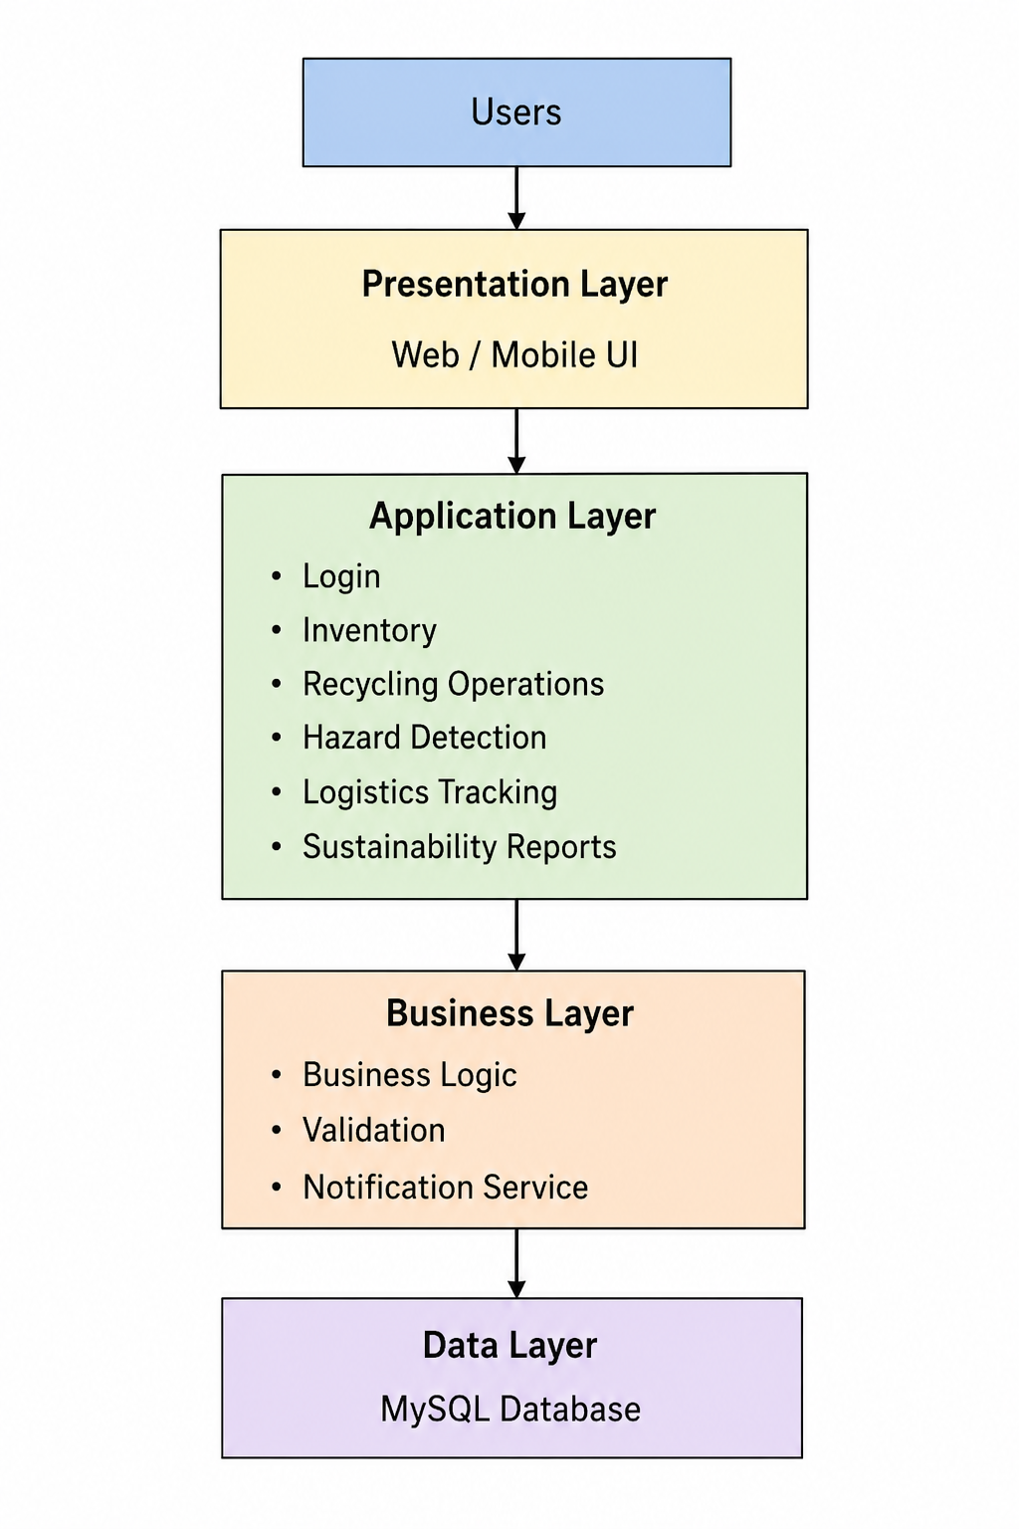

4. Components and Their Interactions:

Presentation Layer:

The Presentation Layer provides the user interface for administrators, managers, recycling operators, safety officers, and logistics managers. Users interact with the system through this layer to perform different operations.

Application Layer:

The Application Layer processes user requests. It manages user authentication, battery inventory, recycling operations, hazard monitoring, logistics tracking, notifications, and report generation.

Business Layer:

The Business Layer contains the business logic of the system. It validates user requests, processes application rules, generates notifications, and controls communication between the application and database.

Data Layer:

The Data Layer stores all system information, including user details, battery records, recycling activities, transportation information, and sustainability reports.

System Workflow:

The user first logs into the system through the Presentation Layer. The request is processed by the Application Layer, where the required module performs the requested operation

5. Quality Attributes

Scalability

The layered architecture allows the system to support additional users and new modules without affecting existing functionalities.

Security

User authentication and role-based access control protect sensitive information from unauthorized access.

Performance

The architecture provides efficient communication between different layers, resulting in faster processing of user requests.

Reliability

The separation of components improves system stability and reduces the possibility of failures.

Maintainability

Each layer can be modified independently, making software maintenance easier and reducing development time.

Availability

The system is designed to provide continuous service with proper database management and regular maintenance.

6. Justification of Architectural Decisions:

The Layered Architecture was selected because it provides a simple and organized structure for developing the Smart Renewable Battery Recycling Platform. Each layer performs a specific responsibility, making the application easier to understand and maintain.

One advantage of this architecture is that changes made in one layer usually do not affect the other layers. This simplifies software testing and future development.

Although communication between multiple layers may slightly increase processing time, the advantages of modularity, maintainability, and scalability outweigh this limitation.

The selected architecture also supports future enhancements such as mobile application support, cloud integration, AI-based hazard prediction, and advanced analytics without requiring major modifications to the existing system.

Conclusion

The Layered Architecture is an appropriate choice for the Smart Renewable Battery Recycling Platform because it provides a structured and modular design. The architecture supports important quality attributes such as scalability, maintainability, reliability, security, performance, and availability. It also provides flexibility for future enhancements and ensures efficient communication between different components of the system. Therefore, this architecture is well suited for developing a reliable and sustainable battery recycling management platform.

